YAME

Yet Another Motion Engine

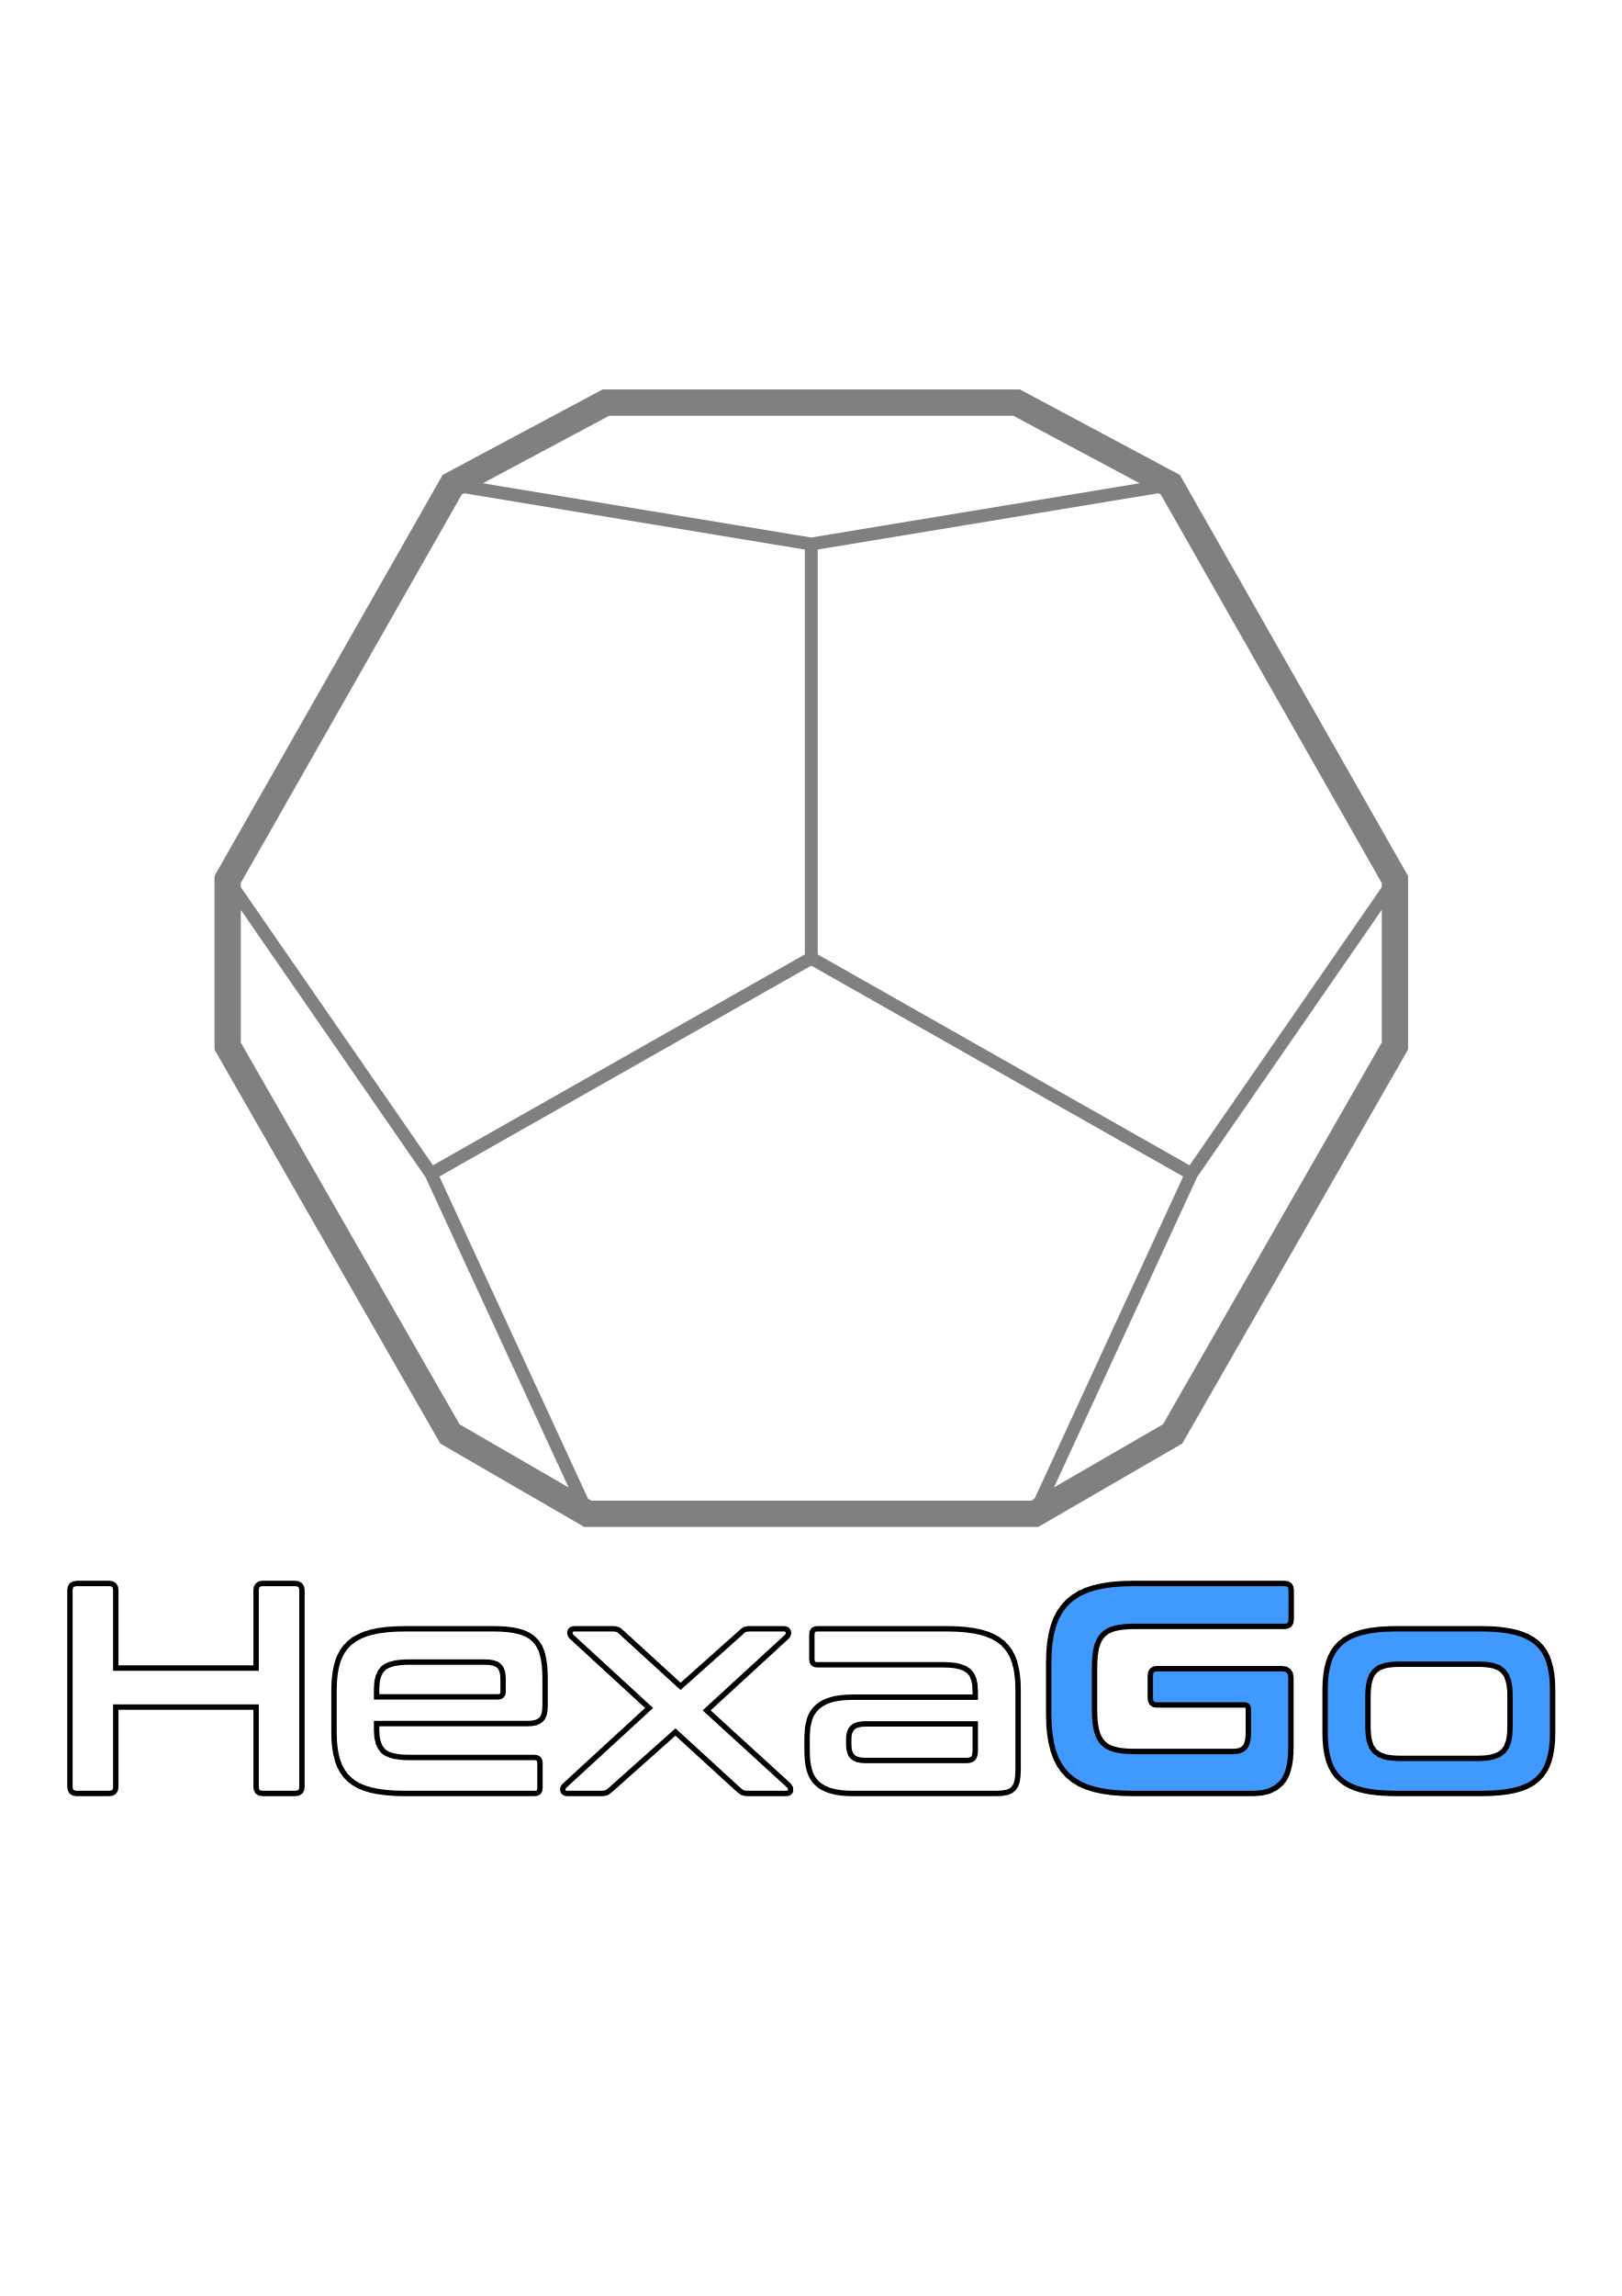

Contents

Installation 3

Uninstallation 3

Coordinate System 4

Child Windows 6

General 6

Raw Data Window 6

Scene View Window 7

Serial Connection Window 8

Crash Detection Window 9

When a crash is detected 10

# Installation

Just download the zip folder and extract it to a location of your choice. Then run *setup.exe* from inside that folder. The rest should be straight forward. After the installation routine you should find YAME in your Start menu.

# Uninstallation

Uninstall YAME through the Windows Settings page. Settings > Apps > Apps & features. Search for “YAME” and hit *Uninstall*. It should remove the application together with all settings.

# Coordinate System

YAME uses a right-handed coordinate system:

X-axis Front (Red)

Y-axis Up (Green)

Z-axis Right (Yellow)

**Z**

**Y**

**X**

So, whenever you come across a subscript x, y, or z it will indicate the Front, Up and Right directions in the aircraft reference system. We deliberately deviated from the engineering standard for aerial vehicles (in which the Z-axis points downwards!).

Positive accelerations are considered…

Ax Longitudinal Acceleration. The acceleration along the aircraft longitudinal axis. Positive values indicate a forward acceleration, negative values indicate a deceleration or an acceleration towards the rear.

Ay Vertical Acceleration. The acceleration along the aircraft vertical axis. Positive values indicate an upward acceleration, negative values indicate a downward acceleration.

Az Lateral Acceleration. The acceleration along the aircraft lateral axis. Positive values indicate a rightward acceleration, negative values indicate a leftward acceleration.

Rotational orientation is also referenced according to the right-hand-rule in respect to the corresponding axis.

This means that the positive…

…yaw direction = yaw left

…pitch direction = nose up

…roll direction = roll right

# Main Window

The Main Window contains a header menu with the following elements:

* File
  + Open
  + Close
  + Quit
* Windows
  + Raw Data
  + Crash Detector
  + Alpha Compensation
  + Rig Configuration
  + Filters
  + DOFs
  + Scene View
  + Serial Connection
  + Motion Control

It also displays some basic status information about the state of the motion data stream.

# Child Windows

## General

You can open YAMEs child windows through the header menu in the main window. Move then around with your left mouse button. The position and visibility status of each window are saved when the application closes to be restored on next startup.

## Raw Data Window

This window shows you the raw telemetry data as it is being exported by the simulator. If you are in doubt whether the connection to the sim is working or you want to troubleshoot really anything on the software, the first step is normally to check if the raw data shows up in this window.

The values revert to default values as soon as there are no new data received for 500ms. Default values are all zeros, except vertical acceleration which defaults to 9.81 m/s2.

## Scene View Window

This window shows you a representation of your rig as YAME sees it. Use your mouse to zoom in/out (scroll wheel). You can pan (center mouse button) and orbit the view (right mouse button).

The colors of the actuators indicate their status:

Blue: Below minimum length.

White: Between min and max length

Red: Above maximum length

In normal operation you should only ever encounter white actuators. Whenever the actuators turn blue or red it means that your physical actuators just hit an end stop.

It might be advisable to configure the rig geometry in such a way that the actuators are a tiny little bit in under-extension (blue) when the rig is in the park position. This makes it easier to confirm at a glance that the rig has indeed reached the park position.

## Serial Connection Window

The Serial Connection window lets you choose the type of controller, open or close the serial connection and displays the bytes of the message that is being transmitted.

Select the type of controller you are using from the dropdown menu. Initially, only two types are supported:

* Motion4Sim
* Thanos AMC AASD15A

If you want other hardware controllers supported and you know their communication protocol, send us an email to [software@hexago-motion.com](mailto:software@hexago-motion.com). Chances are we can add support for it.

You can select the COM port through which YAME communicates with the controllers. If in doubt, you can check Windows’ device manager to find the COM port the controller uses.

## Crash Detection Window

YAME is designed to drive a flight simulator, not a crash simulator! After all, do you really want to find out how it feels to be in a plane crash? Therefore, YAME will stop the motion stream as soon as some key vehicle parameters are exceeded. This window lets you set these parameters.

Ax Longitudinal Acceleration. The acceleration along the aircraft longitudinal axis. Positive values indicate a forward acceleration, negative values indicate a deceleration or an acceleration towards the rear.

Ay Vertical Acceleration. The acceleration along the aircraft vertical axis. Positive values indicate an upward acceleration, negative values indicate a downward acceleration.

Az Lateral Acceleration. The acceleration along the aircraft lateral axis. Positive values indicate a rightward acceleration, negative values indicate a leftward acceleration.

If you are having trouble understanding those accelerations, here’s help for you:

Imagine you put an object on the aircraft glareshield. Now as soon as you apply control inputs this object is subjected to forces that may cause it to slip around.

If you apply thrust, the object wants to slip towards the rear. That was a forward (positive x) acceleration.

If you pull Gs, the object is being compressed downwards. That was an upwards (positive y) acceleration.

If you step on the right rudder and the object slips to the left, that indicates a rightward (positive z) acceleration.

### When a crash is detected

As soon as **any one** of the limiting parameters is exceeded, the application enters the “Crash Detected” state and you can see the red “CRASHED” light illuminate. You get an indication of which value triggered the exceedance detection and how large the exceeding value was.

If the motion controller (see Motion Control Window) was in “Motion” at the time of detection, the platform is automatically commanded back to the “Park” position.

After 5 seconds the light turns yellow indicating that…

* …the platform is recovered to the “Park” position.
* …no exceedance is present.
* …it is now safe to bring the platform back online.

Click on the yellow light to acknowledge the warning and return the crash detector to a “Ready” state.

## Motion Control Window

This window lets you choose which position the rig should go to.

”Park” moves the rig to a position all the way down, where all actuators are fully retracted. This is the initial position on application start and is also used when operation ends, just before depowering the rig.

